**DAILY ONLINE ACTIVITIES SUMMARY**

|  |  |  |  |  |  |  |  |  |
| --- | --- | --- | --- | --- | --- | --- | --- | --- |
| **Date:** | **21/07/2020** | | | | | **Name:** | **NAIPUNYA VINOD NAIK** | |
| **Sem & Sec** | **IV SEM & A SECTION** | | | | | **USN:** | **4AL18CS050** | |
| **Online Test Summary** | | | | | | | | |
| **Subject** | | **NO INTERNALS CONDUCTED** | | | | | | |
| **Max. Marks** | | **30** | | **Score** | | | **--------------** | |
| **Certification Course Summary** | | | | | | | | |
| **Course** | 1. **WEBINAR OF RPA AND ITS APPLICATIONS** 2. **ONLINE WORKSHOP OF PYTHONIC CODING RATHER THAN PYTHON CODING** 3. **KALI LINUX BASICS FOR CYBER SECURITY COURSE** 4. **SETUP CENTOS LINUX 8 AND UBUNTU 20.04** 5. **GOOGLE CLOUD PLATFORM BIG DATA AND MACHINE LEARNING FUNDAMENTALS** | | | | | | | |
| **Certificate Provider** | | | **1) AIET**  **2) AIET**  **3) UDEMY**  **4) UDEMY**  **5) COURSERA** | | **Duration** | | | **1) 2 HRS**  **2) 2 HRS**  **3) 32 MINS**  **4) 1 HR**  **5) 2 WEEKS** |
| **Coding Challenges** | | | | | | | | |
| **Problem Statement: NO PROBLEM STATEMENT GIVEN TODAY** | | | | | | | | |
| **Status:---------------** | | | | | | | | |
| **Uploaded the report in Github** | | | | | **YES** | | | |
| **If yes Repository name** | | | | | <https://github.com/naipunya-naik/PYTHON-WORKSHOP>  <https://github.com/naipunya-naik/daily-progress-report> | | | |
| **Uploaded the report in slack** | | | | | **YES** | | | |

Online Test Details: (Attach the snapshot and briefly write the report for the same).

NO INTERNALS CONDUCTED

Certification Course Details: (Attach the snapshot and briefly write the report for the same).

1. CERTIFICATION COURSE NAME:- **WEBINAR OF RPA AND ITS APPLICATIONS.**

I ATTENDED THE WEBINAR ON 18 JULY 2020.

**TODAY I RECEIVED THE CERTIFICATE**

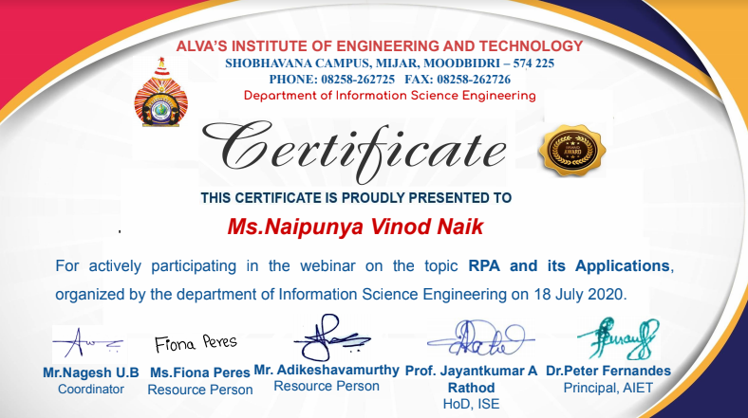

1. **ONLINE WORKSHOP OF PYTHONIC CODING RATHER THAN PYTHON CODING**

* TODAY WE ATTENDED THE FIRST DAY OF FOUR DAY PYTHON WORKSHOP.
* CONDUCTED BY:- DR S.MOHIDEEN BADHUSHA, PROFESSOR, CSE DEPT, AIET.
* WE HAD 2 SESSIONS ON DAY 1.
* I EXECUTED WORKED OUT EXAMPLES AND EXERCISES ON GOOGLE COLAB AND POSTED IT ON MY GITHUB REPOSITORY.

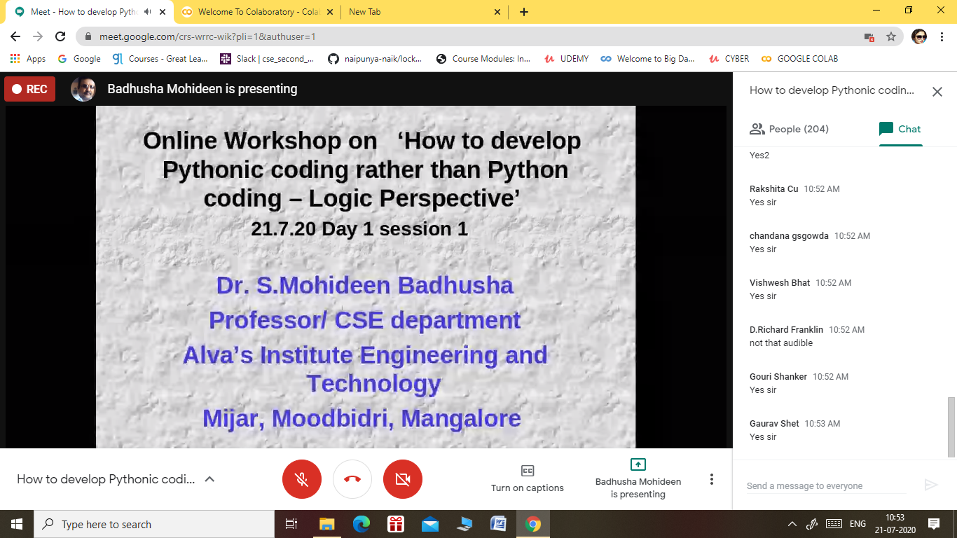

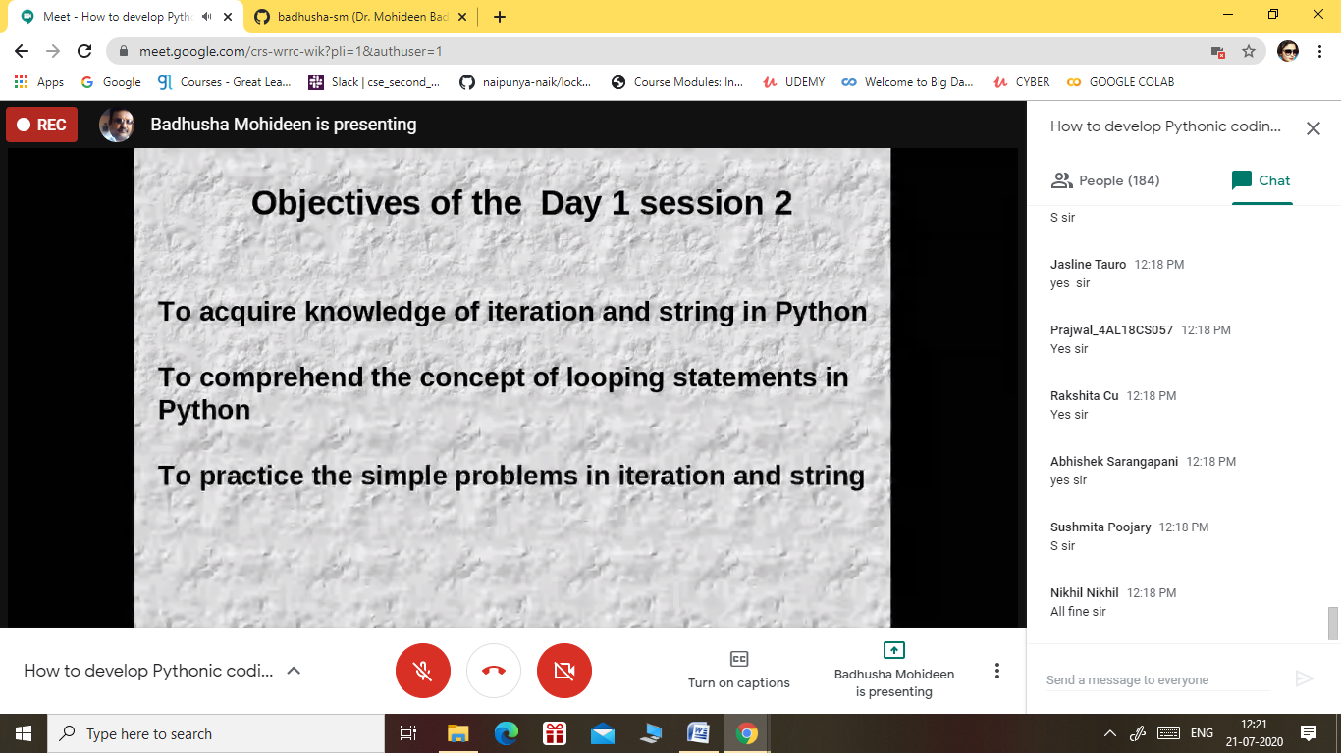

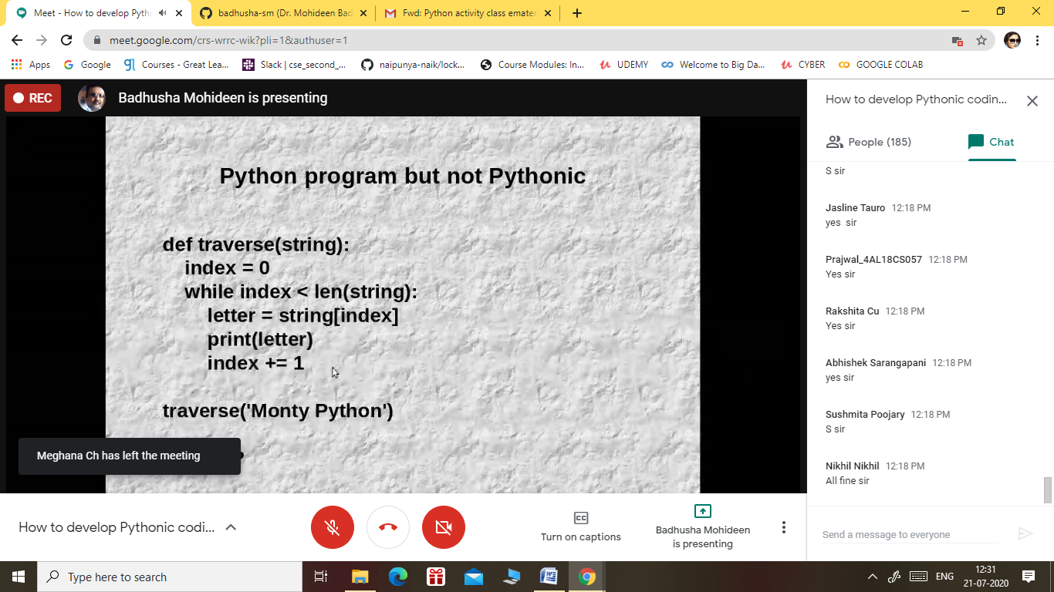

1. CERTIFICATION COURSE NAME:- **KALI LINUX BASICS FOR CYBER SECURITY COURSE.**

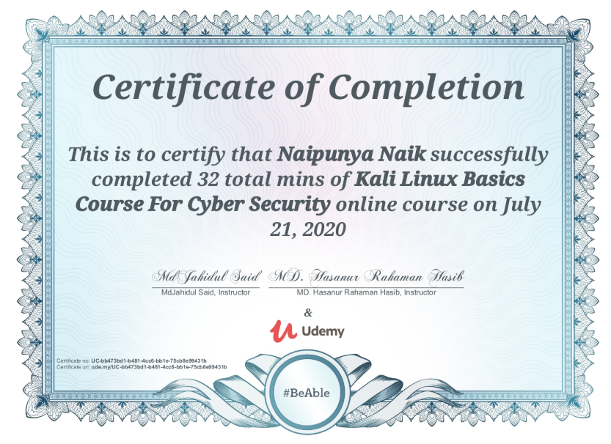

4)CERTIFICATION COURSE NAME:- **SETUP CENTOS LINUX 8 AND UBUNTU 20.04**

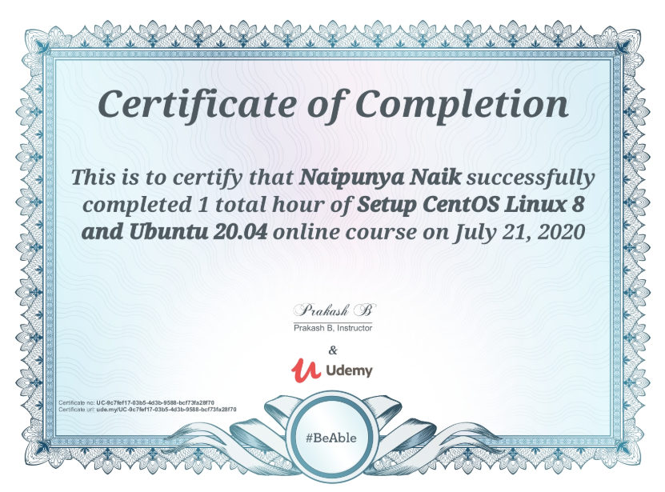

5)CERTIFICATION COURSE NAME:- **GOOGLE CLOUD PLATFORM BIG DATA AND MACHINE LEARNING FUNDAMENTALS**

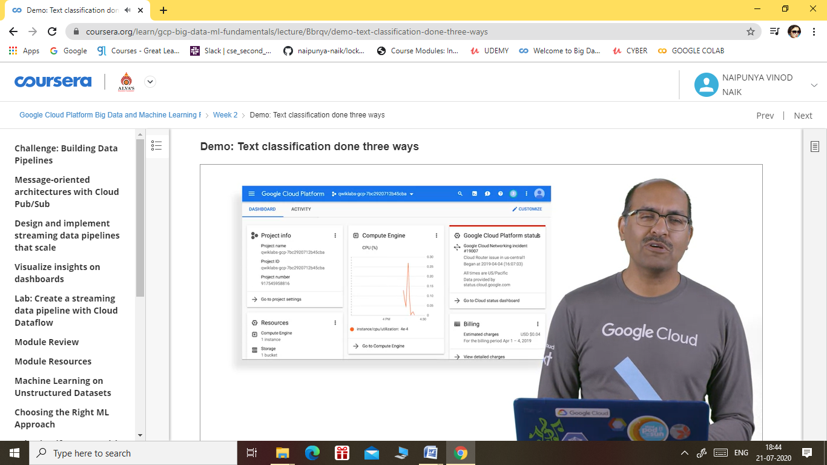

Coding Challenges Details: (Attach the snapshot and briefly write the report for the same).

NO PROBLEM STATEMENTS GIVEN TODAY